Nama : Ratri Ika Sulfiani

NIM/Kelas : 23051204347/J

Prodi : Teknik Informatika

Matkul : Pemograman Dasar

**FLOWCHART**

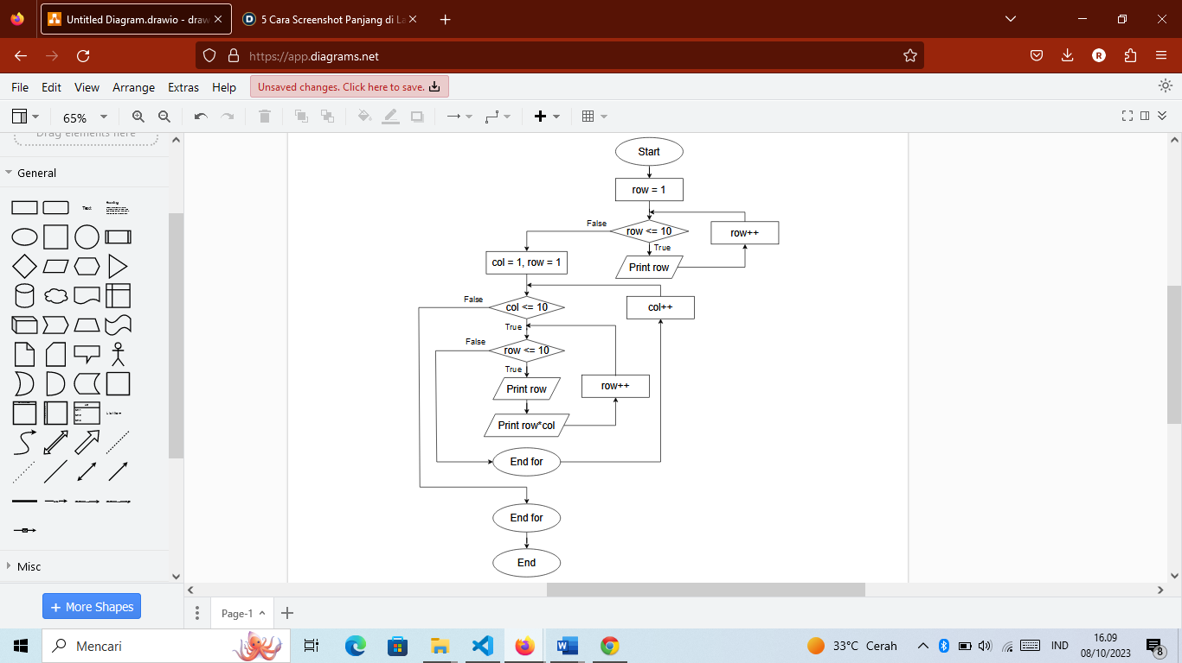

**PSEUDOCODE**

Start

For row in 1 to 10 do

Print row

Next for

For col in 1 to 10 do

For row in 1 to 10 d0

Print col

Print col*row

End for

End